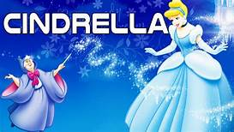 My favourite book name is Cinderella.

This book is very interesting.

In this book there are six characters.

The main characters are Cinderella and the Prince.

The best scene was when Cinderella’s shoe fell on the stairs and prince went to her house and gave her beautiful shoes.

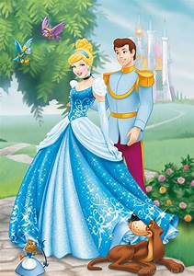The Author of this book is Disay Fisher.

This book was written in 1966.

I love this book.